I have a dream…

Personal Narrative: Writing about your dream for the world.

Name:

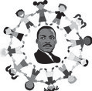

**Dr. Martin Luther King, Jr. is remembered for his inspiring speeches to**

**help promote civil rights. His most famous speech began, “I have a dream… “ King spoke of his dream of a world where people were judged by their character instead of by their race. What is your dream? Write a personal**

**narrative that tells about your dream for the world. What would you change, and why?**

Copyright ©2012 K12Reader - [http://www.k12reader.com](http://www.k12reader.com/)